How Many Cookies Can you fit in your car?
Need to know how many cases of Girl Scout Cookies you can fit in your car? If your car is empty except for the driver and is tightly packed with cases of Girl Scout Cookies, it should hold the following:
Vehicle Approx. # of Cases
Compact or 3-Door 23
Hatchback or Small Wagon 25-30
Mid-Size Sedan (Using back seat and trunk) 35
8-passenger mini-van or sport utility 60
Full-size station wagon 75
Standard pickup truck 100
Full-size van with seats 150
Full-size van without seats 200

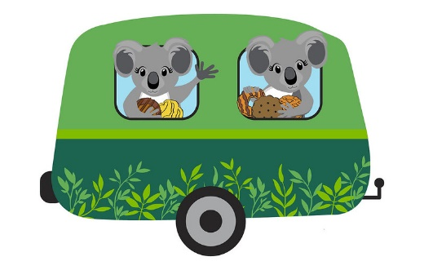
Reminder the less you have in your vehicle the more space you will have for cookies!!

